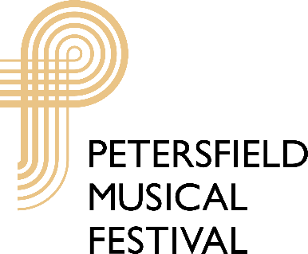
The Michael Hurd Fund for Young Musicians
Festival of Young Composers 2023 – 2024
Entry Form
Administrator: Sue Bint, 11 Eleanor Close, Passfield, Hants. GU30 7TX
Tel. 01428 751963 email bintsw1@btinternet.com

Name of Entrant: _______________________________________________Date of birth: ____/_____/__________
Home address: __________________________________________________________________________________
_______________________________________________________________________________________________
_______________________________________________________________________________________________
Tel: ___________________________________________ Email: __________________________________________
Name & address of School/College/Private Music Teacher_______________________________________________
_______________________________________________________________________________________________
_______________________________________________________________________________________________
Tel: ___________________________________________ Email: __________________________________________
Date of entry ___________________________________ Category A/B: ____________________________________
Age group for entry (please circle): 14 years and under/17 years and under/19 years and under
Title of composition ______________________________________________________________________________
Instrumentation/voices used: ______________________________________________________________________
_______________________________________________________________________________________________
We confirm that the enclosed composition is the entrant’s original work.
Signed: (Please also print name below)
_______________________________ _____________________________
Entrant’s signature Signature of Teacher/Parent/Guardian
_______________________________ _______________________________
Registered Charity No. 900489

